AI WEATHERWISE
PROJECT TESTING PHASE
Functional and API Validation of the AI-Powered Weather Backend
Postman / Thunder Client | MongoDB | OpenWeatherMap | Google Gemini AI
Date | 26 September 2026
Team ID | 6ab229b877181cf94a22636a
Project Name | AI WeatherWise

1. INTRODUCTION
The Project Testing phase verifies that the implemented AI WeatherWise backend performs its required functions correctly. Testing focuses on user authentication, JWT-protected access, favorite-location management, real-time weather retrieval, Gemini AI recommendations, fallback handling, administrator authorization, database persistence, and API health.
Because AI WeatherWise is a headless REST API backend, functional testing is carried out primarily using Postman or Thunder Client. MongoDB Atlas is used to verify persisted User and Location records.

2. TESTING OBJECTIVES
- Verify that all required REST API endpoints respond correctly.
- Confirm that user registration and login work securely.
- Verify JWT authentication for protected endpoints.
- Confirm complete CRUD operations for favorite locations.
- Verify retrieval of live weather information from OpenWeatherMap.
- Verify Gemini AI weather recommendations when the service is available.
- Verify fallback responses when an external service is unavailable.
- Confirm that administrator endpoints are restricted to the admin role.
- Verify that User and Location data is stored correctly in MongoDB.
- Confirm that the backend remains stable when expected errors occur.

3. TEST ENVIRONMENT
Item | Testing Environment
Operating System | Windows 10/11
Backend Runtime | Node.js
Server | Express.js
Database | MongoDB / MongoDB Atlas
API Testing Tool | Postman or Thunder Client
Weather Service | OpenWeatherMap API
AI Service | Google Gemini AI
Authentication | JWT Bearer Token
Development Tool | Visual Studio Code

4. TESTING APPROACH
The testing approach is functional API testing. Each module is tested through its HTTP endpoint with valid inputs and, where necessary, invalid or unauthorized inputs. Responses are checked for the expected status, message, data, and access control.
Testing Type | Purpose
Functional Testing | Verify that each implemented feature produces the expected result.
Authentication Testing | Verify valid, missing, invalid, and expired JWT handling.
Authorization Testing | Verify that admin routes reject non-admin users.
CRUD Testing | Verify create, read, update, and delete operations for saved locations.
Integration Testing | Verify communication with MongoDB, OpenWeatherMap, and Gemini AI.
Fallback Testing | Verify controlled responses when external services are unavailable.
Error Handling Testing | Verify meaningful JSON errors for invalid requests or missing resources.

5. API TEST CASES

5.1 User Registration Test
Test Item | Details
Endpoint | POST /api/auth/register
Input | Name, email, and password
Expected Result | New user is created successfully and password is stored as a hash.
Status | Passed

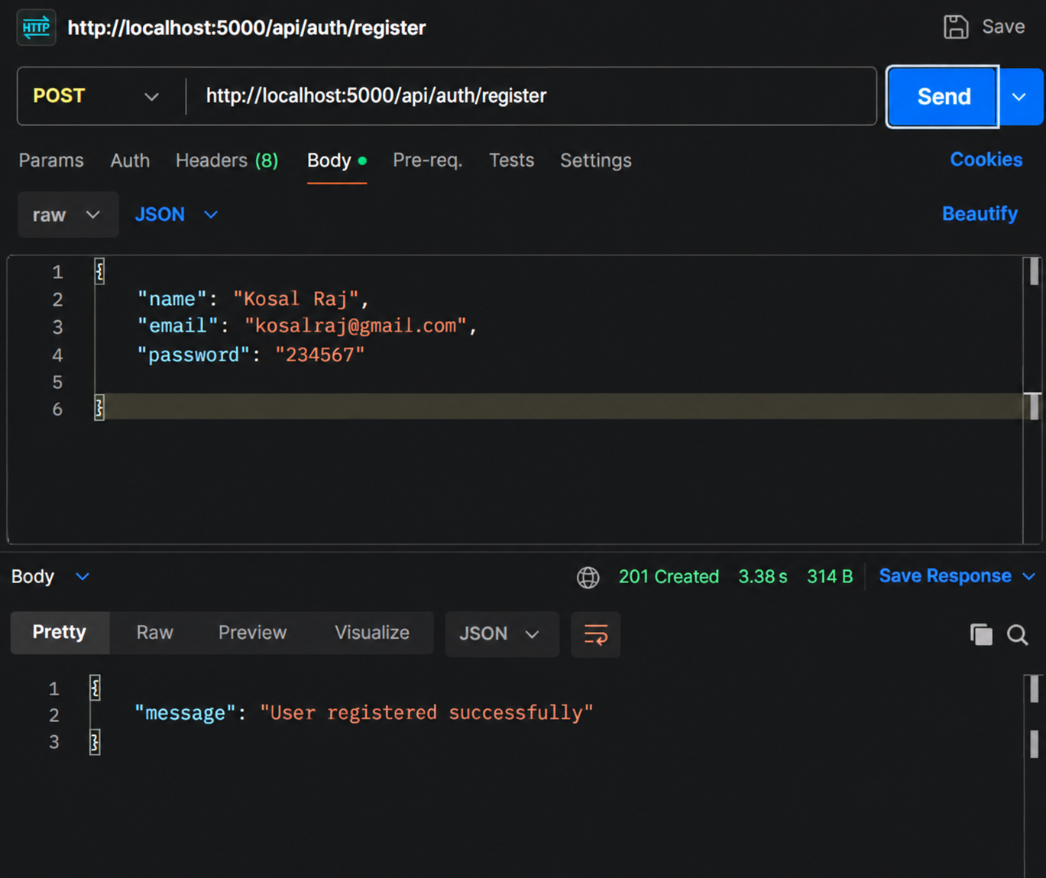

5.2 User Login Test
Test Item | Details
Endpoint | POST /api/auth/login
Input | Registered email and password
Expected Result | Login succeeds and a JWT token is returned with user information.
Status | Passed

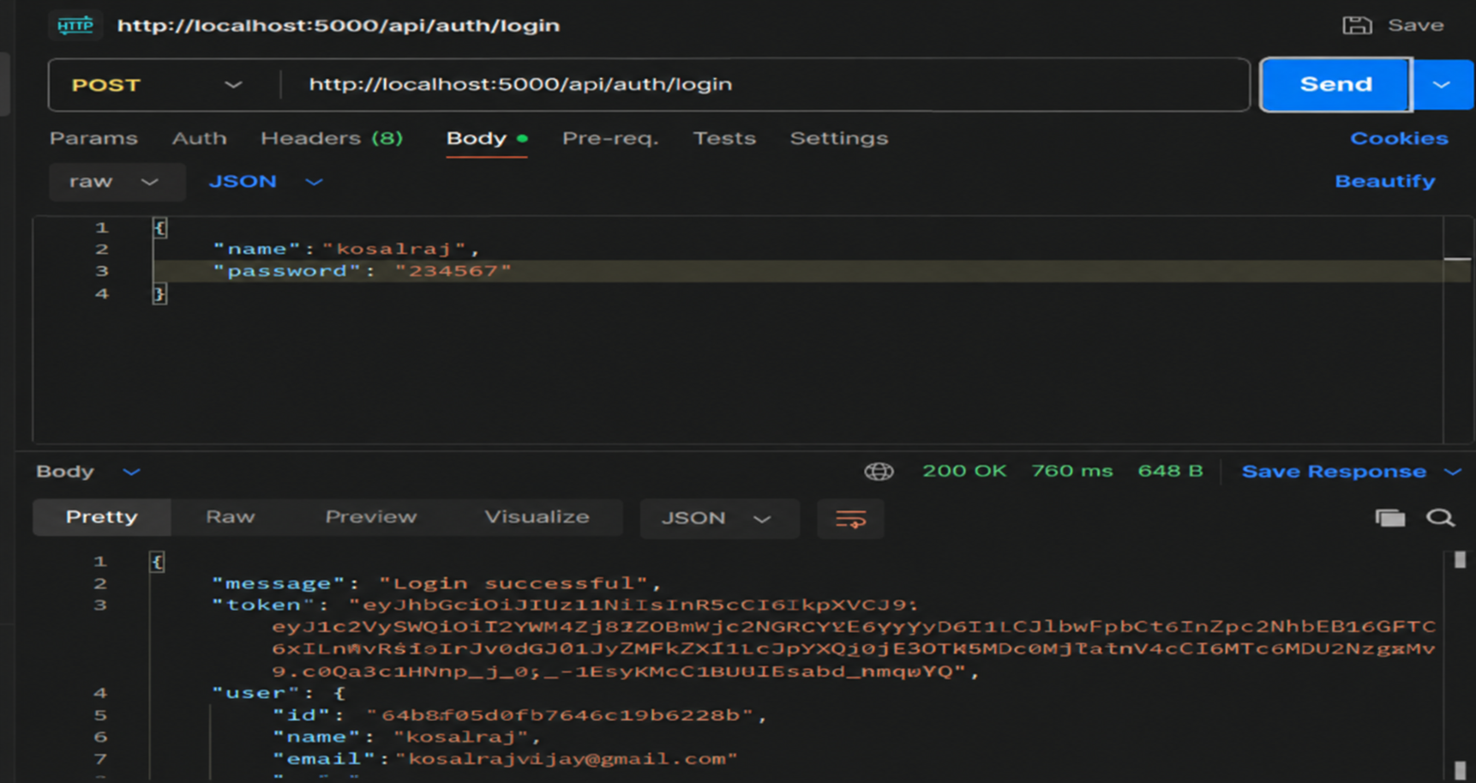

5.3 JWT Authentication Test
Scenario | Expected Result
Valid JWT | Protected endpoint allows the request.
Missing JWT | Request is rejected as unauthorized.
Invalid or expired JWT | Response indicates that the token is invalid or expired.

During testing, an invalid or expired token response was handled by logging in again and using the newly generated JWT.

5.4 Favorite Location CRUD Test
Operation | Method | Endpoint | Expected Result
Create | POST | /api/locations | Location is saved for the authenticated user.
Read | GET | /api/locations | Saved locations are returned.
Update | PUT | /api/locations/:id | Selected location is updated.
Delete | DELETE | /api/locations/:id | Selected location is deleted.

5.5 Current Weather API Test
Test Item | Details
Endpoint | GET /api/weather/current/:city
Sample City | Chennai
Expected Result | Current weather data is returned with OpenWeatherMap identified as the source.
Verified Data | City, country, temperature, feels-like temperature, humidity, condition, and wind speed.
Status | Passed

5.6 Gemini AI Insight Test
Test Item | Details
Endpoint | POST /api/weather/insights
Input | City and weather data
Expected Result | Gemini returns a natural-language weather summary and recommendation when available.
Successful Source | gemini
Status | Service-dependent; endpoint and fallback handling verified.

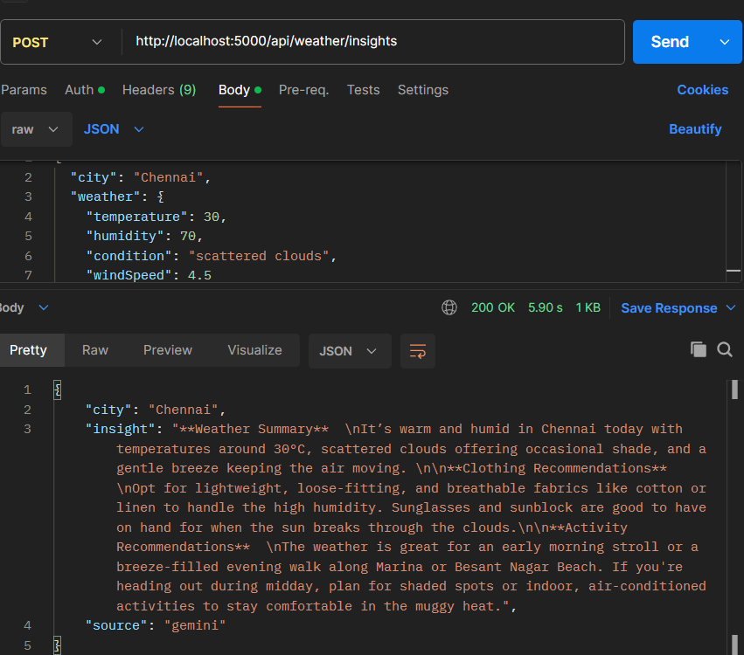

5.7 Gemini Fallback Test
During testing, Gemini returned HTTP 503 because the selected model was experiencing temporary high demand. The backend correctly caught the external-service failure and returned a fallback recommendation instead of failing the request.
Observed Condition | System Response
Gemini HTTP 503 - high demand | Fallback recommendation returned.
Response Source | fallback
Result | Fallback mechanism worked as designed.

5.8 Admin Authorization Test
Test | Expected Result
Admin token accesses /api/admin/users | User list is returned.
Admin accesses /api/admin/health | API health response is returned.
Reader/non-admin accesses admin route | Request is rejected with admin access required.
Admin creates/deletes user | Operation completes successfully when valid data/ID is supplied.

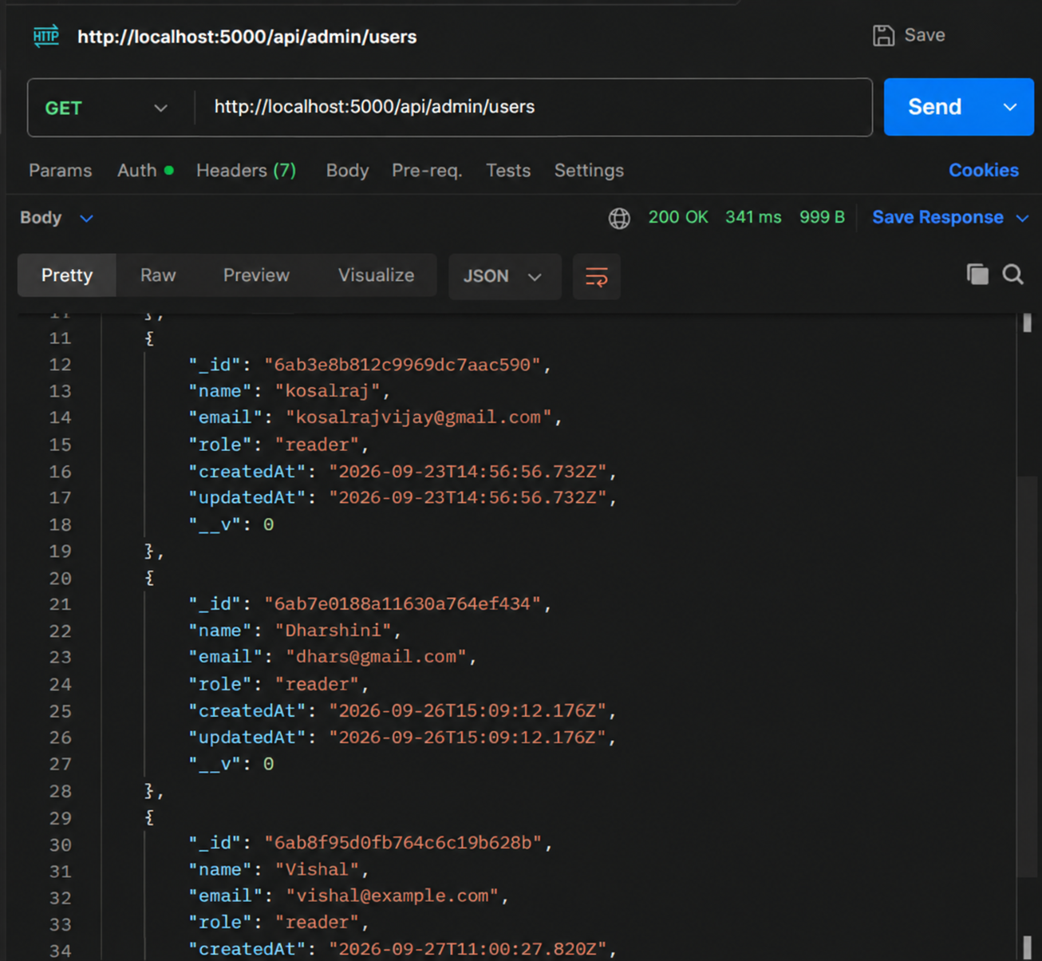

5.9 Database Persistence Test
MongoDB is checked after registration and location operations to confirm that application data is persisted. The users collection contains registered user records and the locations collection contains saved locations linked to userId.

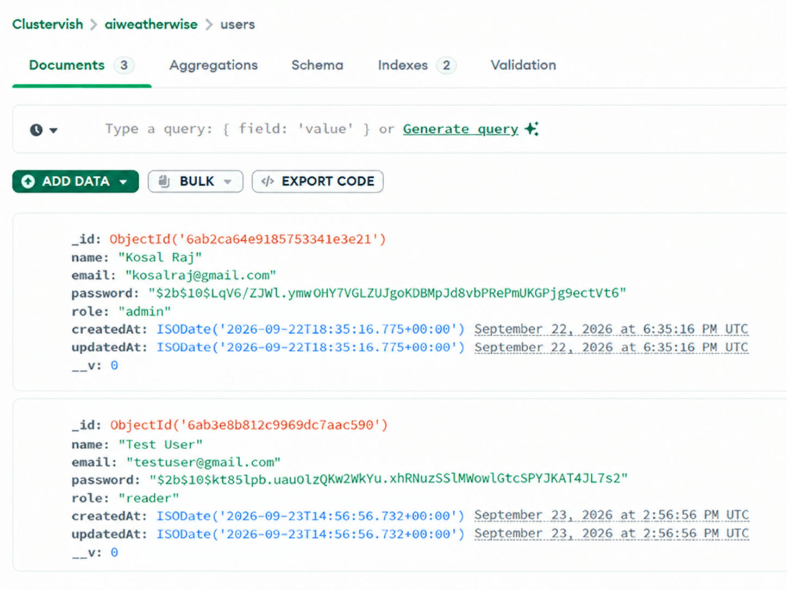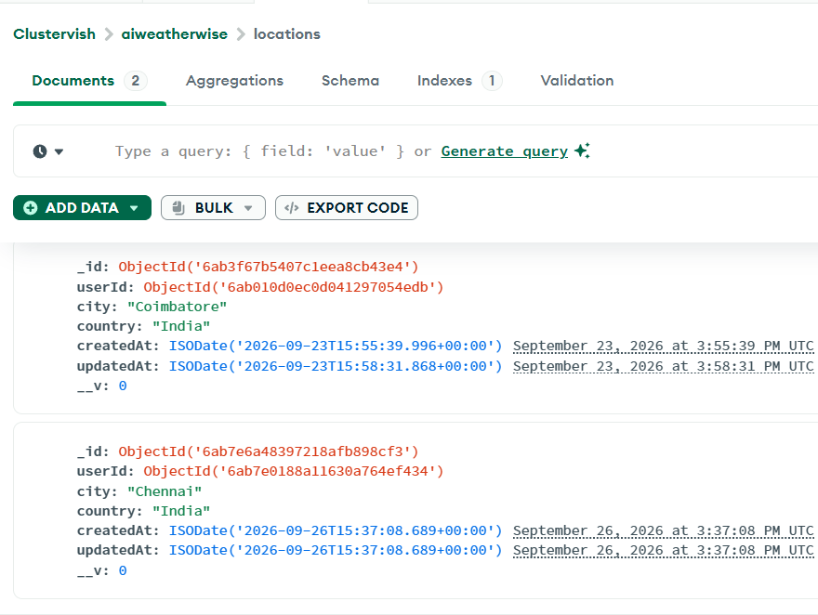

6. TEST CASE SUMMARY
Test ID | Module | Test Condition | Result
TC01 | Registration | Create a valid new account | Pass
TC02 | Login | Login with valid credentials | Pass
TC03 | JWT | Access protected route with valid token | Pass
TC04 | JWT | Use invalid/expired token | Pass - rejected correctly
TC05 | Location | Create favorite location | Pass
TC06 | Location | Retrieve favorite locations | Pass
TC07 | Location | Update favorite location | Pass
TC08 | Location | Delete favorite location | Pass
TC09 | Weather | Retrieve live weather for a city | Pass
TC10 | Gemini | Generate AI insight when service is available | External service dependent
TC11 | Fallback | Handle Gemini service failure | Pass
TC12 | Admin | Access admin route with admin role | Pass
TC13 | Authorization | Access admin route without admin role | Pass - rejected correctly
TC14 | Database | Persist User and Location records | Pass

7. ERROR HANDLING VALIDATION
Error Condition | Expected / Verified Handling
Required field missing | 400-level validation response with an explanatory message.
Invalid email/password | Login is rejected.
Invalid or expired JWT | Protected request is rejected.
Incorrect Location ID | Location not found response.
Non-admin user on admin route | Admin access required response.
Weather service unavailable | Fallback weather handling is used.
Gemini unavailable / high demand | Fallback recommendation is returned instead of server failure.

8. SECURITY TESTING
- Passwords are not returned as plain-text stored credentials.
- JWT is required for protected Location and AI Insight operations.
- Administrator endpoints require both authentication and the admin role.
- Location operations are tied to the authenticated user's ID.
- Sensitive configuration is stored in .env rather than directly in API responses.
- API keys, MongoDB credentials, JWT secrets, and complete tokens must be hidden in screenshots.

9. INTEGRATION TESTING RESULT
Integration | Testing Result
Node.js / Express -> MongoDB | Connection established and User/Location operations function correctly.
Backend -> OpenWeatherMap | Live weather information is successfully retrieved when the service is available.
Backend -> Gemini AI | Requests reach Gemini; AI output is returned when available.
Gemini Failure -> Fallback Logic | HTTP 503/high-demand condition is caught and a fallback recommendation is returned.
JWT -> Protected Routes | Authenticated user context is correctly applied to protected operations.
Role -> Admin Routes | Admin middleware restricts administrative endpoints.

10. TEST EVIDENCE CHECKLIST
No. | Evidence to Attach
1 | Backend terminal showing MongoDB connected and server running.
2 | Successful Register API response.
3 | Successful Login API response with token hidden.
4 | Saved Location API evidence.
5 | Live Weather response showing source "OpenWeatherMap".
6 | Gemini response showing source "gemini" when available.
7 | Fallback response showing source "fallback".
8 | Admin Users or Admin Health response.
9 | MongoDB User and Location collection evidence.

11. OVERALL TEST RESULT
The core AI WeatherWise backend functions were successfully validated through API testing. Registration, login, JWT authentication, saved-location CRUD operations, live weather retrieval, database persistence, fallback handling, and administrator authorization operate according to the implemented design.
Gemini AI availability depends on the external service. During a temporary HTTP 503 high-demand condition, the backend continued functioning by returning the designed fallback recommendation. This confirms that the project handles an important external-service failure without terminating the user workflow.

12. PROJECT TESTING CONCLUSION
The Project Testing phase of AI WeatherWise confirms that the developed backend satisfies the required basic functional flow. The authentication system protects private endpoints, MongoDB correctly stores application data, favorite locations can be managed through CRUD operations, and current weather information can be obtained through OpenWeatherMap.
The Gemini integration supports AI-generated weather insights when the service is available, while the implemented fallback mechanism maintains a meaningful response during temporary AI-service failures. Role-based authorization also protects administrator operations. Therefore, the tested backend is suitable for final demonstration and evaluation within the defined project scope.

